Revision: | 1.5.1

Product code: | SmartRF TrxEB
Product name: | SmartRF Transceiver Evaluation board

Assembly details for TrxEB 1.7.0

This document contains important information about the Transceiver Evaluation Board. Please read carefully before starting the manufacturing process. All questions can be directed to Magnus Wines (m.wines@ti.com).

Mounting of the connectors for the LCD display:

The female connectors P300, P301 and P302 are the connectors for the LCD module. These pin sockets do not appear on the assembly drawing or in the “pick & place” list. P300, P301 and P302 should, however, be mounted by the pick and place machine. Note the location of P300, P301 and P302:

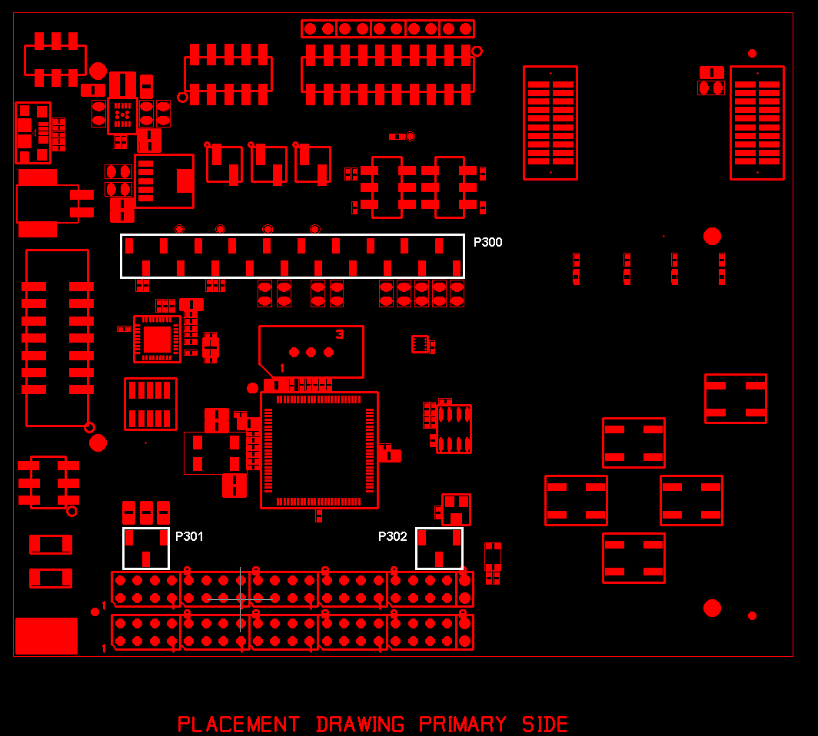

Mounting of the LCD

Mounting of the LCD should be done as part of the normal assembly of the board. Note that the connectors are very tight, so special care must be taken during the mounting process to avoid breaking the LCD.

Parts on the backside of the board

There are no components on the backside of the board, except for the battery holders.

Mount jumpers as follows:

- P4: None
- P17: 3-4, 9-10
- P10: 1-2
- P15: 1-2
- P13: 1-2

Position of switches:

Switch S1 in position “SmartRF”
Switch S2 in position “Enable”
Switch S5 in position “OFF”

NB! Please note that the switches give the right “feel” when moving the slider. It should be firm and there should be a small “click” when the position is changed. We have observed that a few of these switches are not working as they should (bad mechanics).

Alternate parts:

If the part TPS63000 is unavailable, use TPS63001 instead. In that case, R68 should be replaced with a 0 Ohm resistor and R69 should not be mounted.

If the part SS-VX-1X20R-LF is not available, use 019-1-020-D-H1STF-XR1 from MPE Garry instead.

If the part SS-VX-1X03R-LF is not available, use 019-1-003-D-H1STF-XR1 from MPE Garry instead.

Revision history
Revision | Date | Description/Changes
1.5.1 | 2011-07-20 | This version of the document is valid for TrxEB version 1.7.0.  The LCD should now be mounted as part of the normal production/assembly flow.
1.5 | 2011-05-26 | This version of the document is valid for TrxEB version 1.6.0.  No need for special LCD mounting procedure with the new LCD sockets.  Alternate parts for SS-VX sockets.
1.4 | 2011-04-29 | The assembly note is applicable for all current revisions of the board.
1.3 | 2011-04-14 | This document is valid for both version 1.3.0 (PCB rev 1.1) and 1.5.0 of TrxEB.  Added note about special procedure for mounting of the LCD.  Corrected name of switch S6 to S5.  Added note about quality of switches.
1.2 | 2011-04-07 | Specify that the LCD shall be mounted as part of the production test.  Updated information about which jumpers to mount.
1.1 | 2010-12-10 | Updated for revision 1.5.
1.0 | 2010-08-04 | First version, targeted for the first assembly of the board (rev 1.3)

